**ITT 450**

**COMMON LINUX COMMANDS:**

1. ls command.

one of the most frequently used command in Linux. I believe **ls** command is the first command you may use when you get into the command prompt of Linux Box

ls syntax: ls [options] [file/dir]

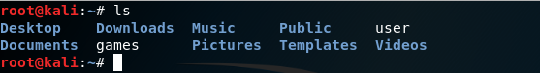

Some of ls command options:

-a = list all files including hidden file starting with ‘.’

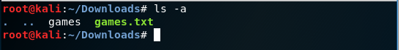

--all = do not ignore entries starting with .

-1 = **ls -l** (**-l** is character not one) shows file or directory, size, modified date and time, file or folder name and owner of file and it’s permission

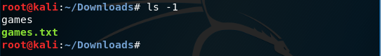

-d = list directories - with ‘*/’

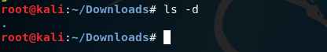

-r = list in reverse order



-s = list file size

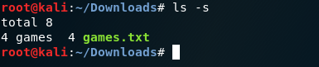

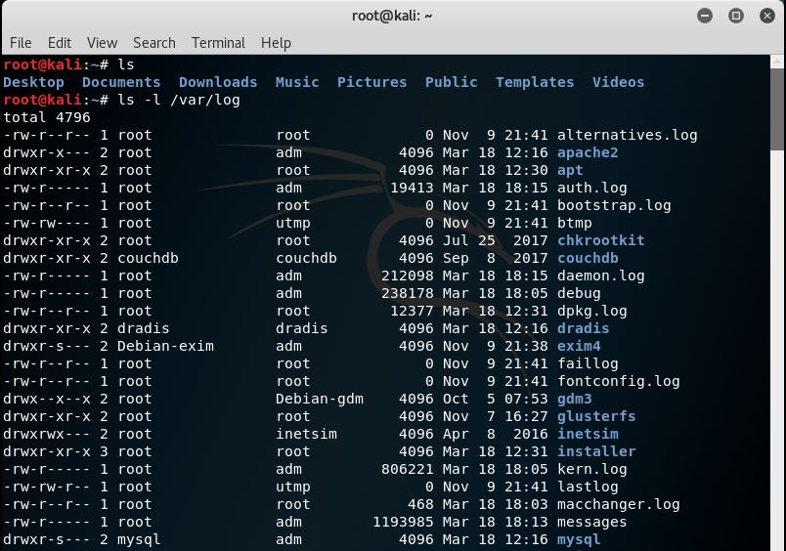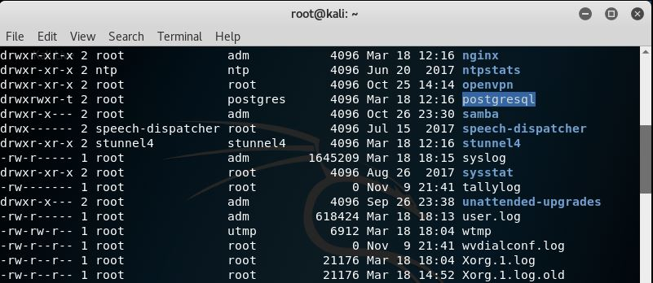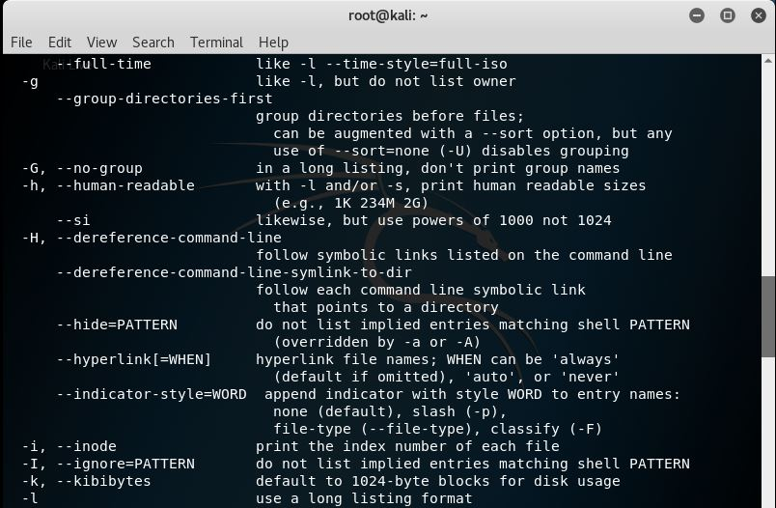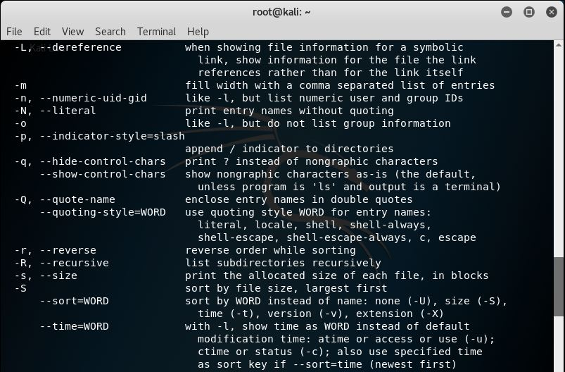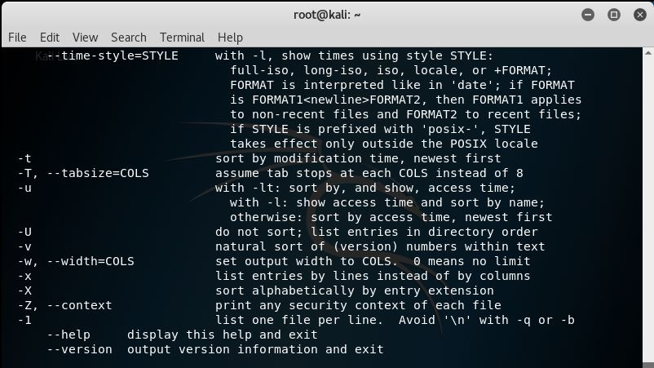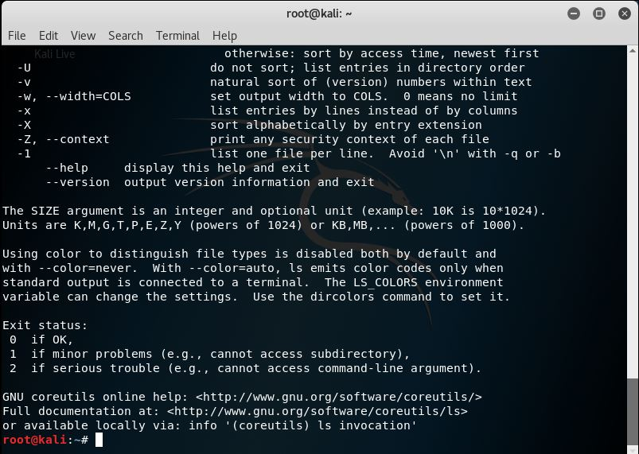

1. cd command.

A Linux command to change the directory/folder of the terminal’s shell.

Note: Pressing *tab* button will auto complete the directory name.

cd syntax: cd [directory]

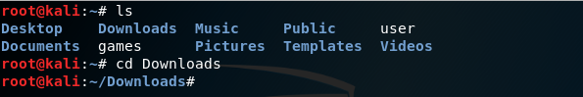

Extra: cd = will change to home directory

cd / = will change to root directory

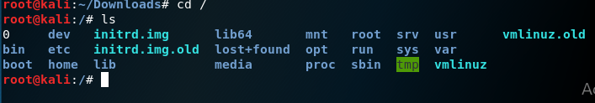

cd .. = will change to parent directory

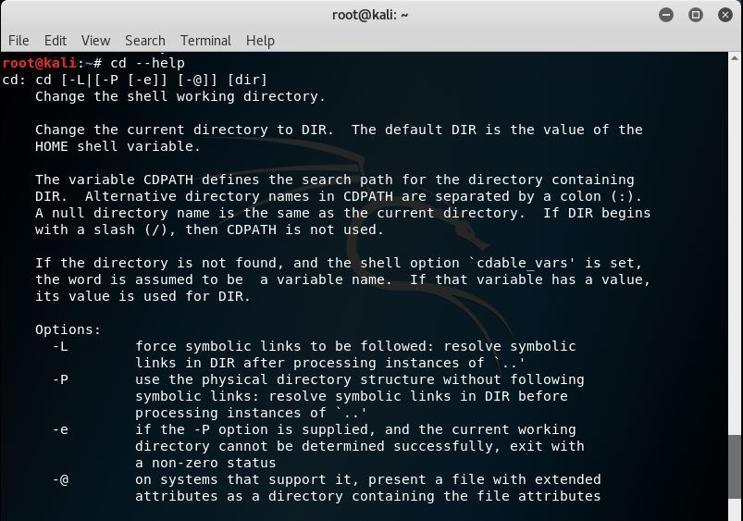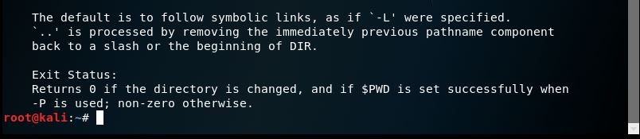

1. mv command.

The **mv** command moves, or [renames](https://www.computerhope.com/jargon/r/rename.htm), files and directories on your [filesystem](https://www.computerhope.com/jargon/f/filesyst.htm).

syntax: mv [options] source destination

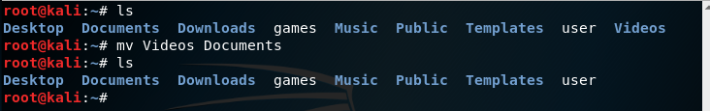

mv command options:

--backup = Make a backup of each existing destination file, using the version control method *vcm*. If *vcm* is omitted, **--backup** behaves the same as **-b** (backups are created, using the default version control method). See [Backing up files](https://www.computerhope.com/unix/umv.htm#backup-files) for details

-b = Like **--backup**, but does not accept a backup method. Instead, the method specified by the **VERSION_CONTROL** environment variable is used. Simple backups are created if the variable is not set

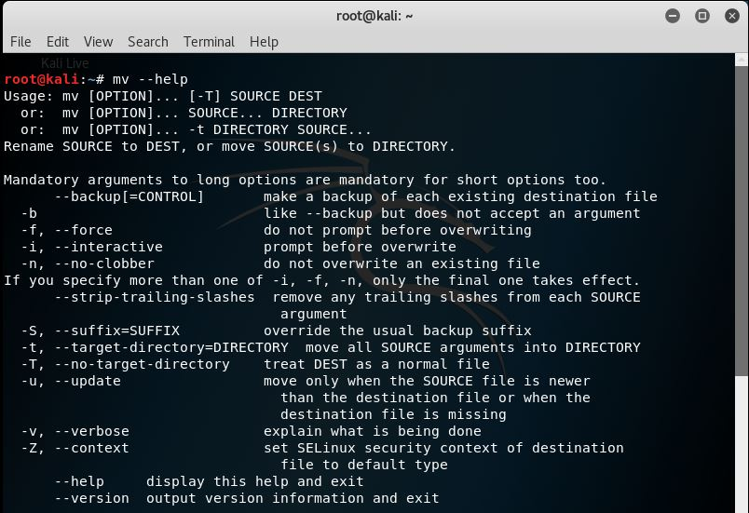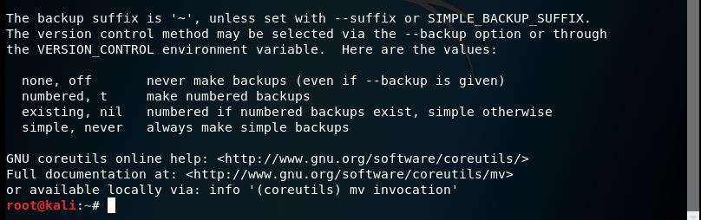

4. rm command.

-rm (short for remove) is a basic UNIX command used to remove objects such as files, directories, device nodes, symbolic links, and so on from the filesystem. To be more precise, rm removes references to objects from the filesystem.

rm syntax: rm [options] file

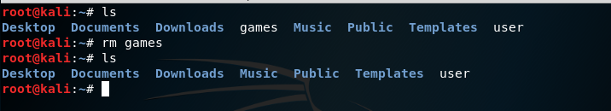

Some of rm command options:

-f, --force = ignore non-existent files, never prompt

-i = prompt before every removal

-v, --verbose = explain what is being done

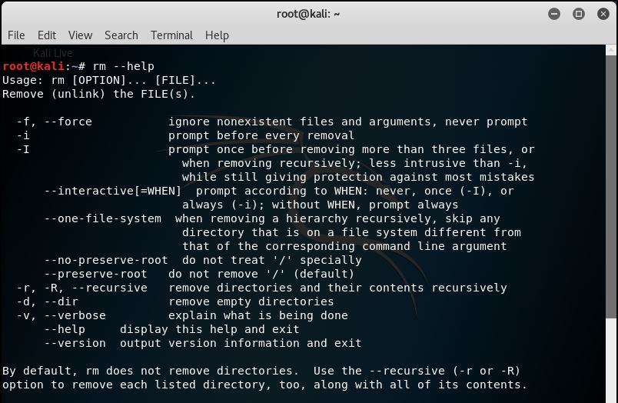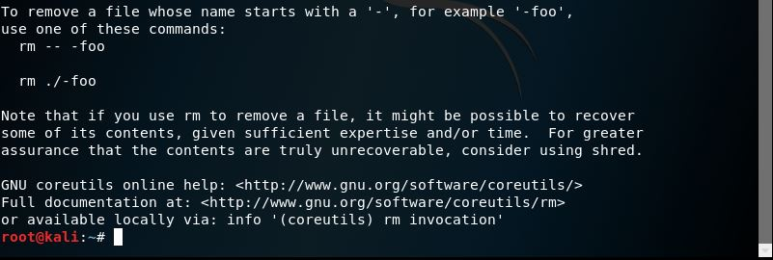

1. mkdir/rmdir commands.

mkdir

-The mkdir (make directory) command in the Unix, DOS, OS/2, and Microsoft Windows operating systems and in the PHP scripting language is used to make **a new directory**.

rmdir = delete directory

The syntax: mkdir filename

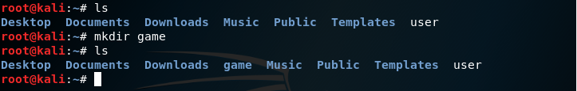

Some of mkdir/rmdir command options:

-m = set file mode (as in chmod). (only for mkdir)

-p = mkdir-no error if existing, make parent directories as needed

rmdir-remove directory and its ancestors

-v = mkdir-print a message for each created directory

rmdir-output a diagnostic for every directory processed

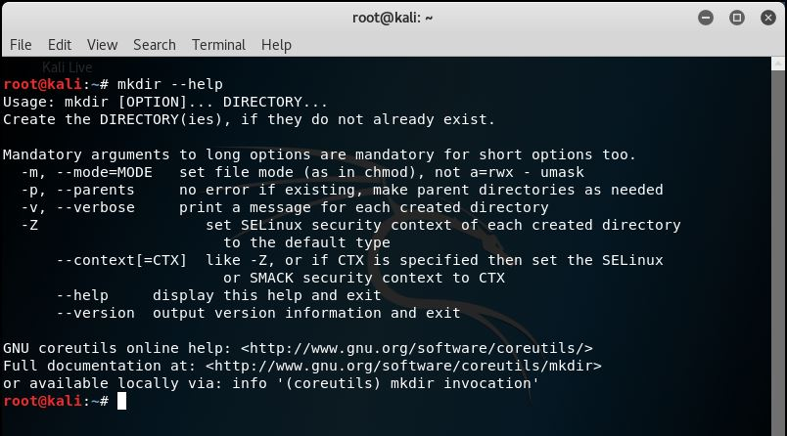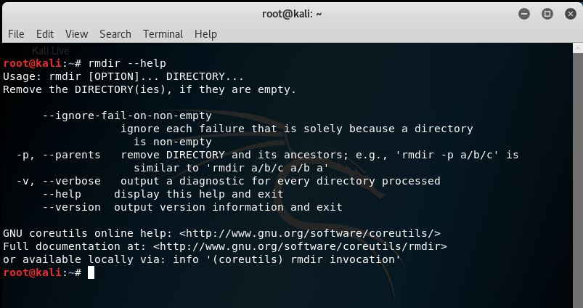

1. touch command.

A command that change file timestamps.

touch syntax: touch [option] file

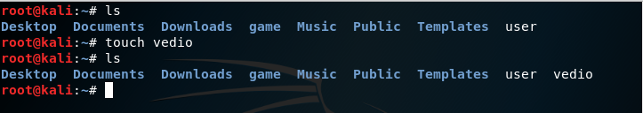

Some of touch command options:

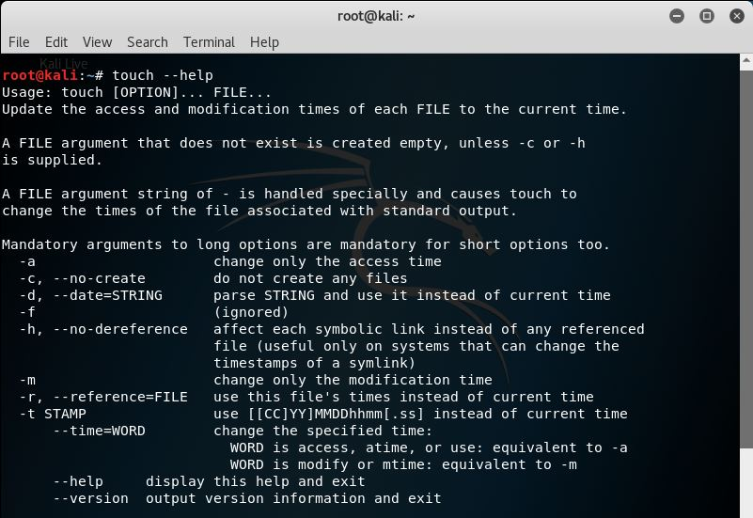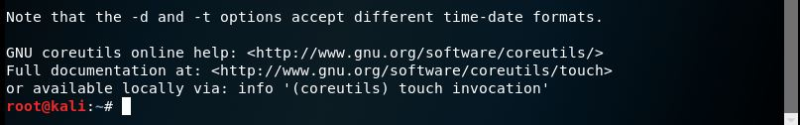

1. cat command.

Is used to display the content of text files and to combine several files to one file.

Note: this command does not accept directories.

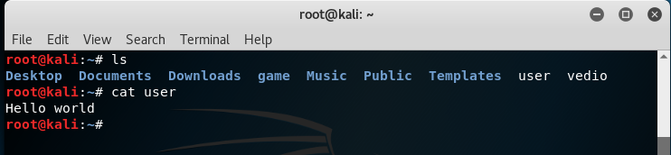

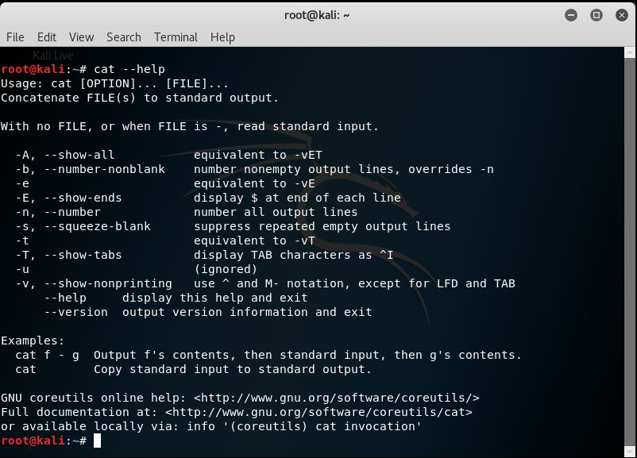

Some of cat command options:

-b = add line numbers to non-blank lines

-n = add line numbers to all lines

1. pwd command.

-The pwd command (print working directory) writes the full pathname of the current working directory to the standard output.

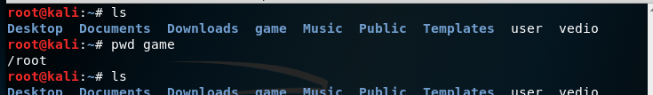

1. file command.

Used to determine file type.

file syntax: file [options] [-f namefile] [-F separator] [-m magicfiles]…….

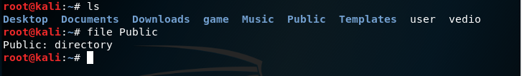

Some of file command options:

-f = read the names of the files to be examined from namefile

-F = use the specified string as the separator between the filename and the file result returned. Defaults to “:”

-m = specify an alternate list of files containing magic numbers.

-b = do not prepend filenames to output lines (brief mode)

-N = don’t pad filenames so that they align in the output

-v = chmod-output a diagnostic for every file processed

chown-verbosely describe the action (or non-action) taken for every file.

-c = chmod-like verbose but report only when a change is made

chown-verbosely describe the action for each file whose ownership actually changes

1. more/less command.

more = to view a text file one page at a time, press spacebar to go to the next page.

less = almost the same as more command with some exception:

1. can navigate the page up/down using less command, not possible in more command.
2. can search a string in less command.
3. more was fairly limited and any additional development has stopped.

The syntax: more [option] [-num] filename

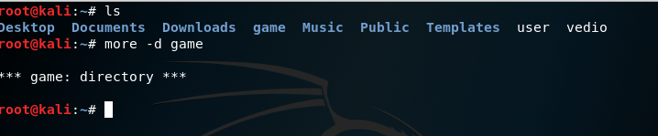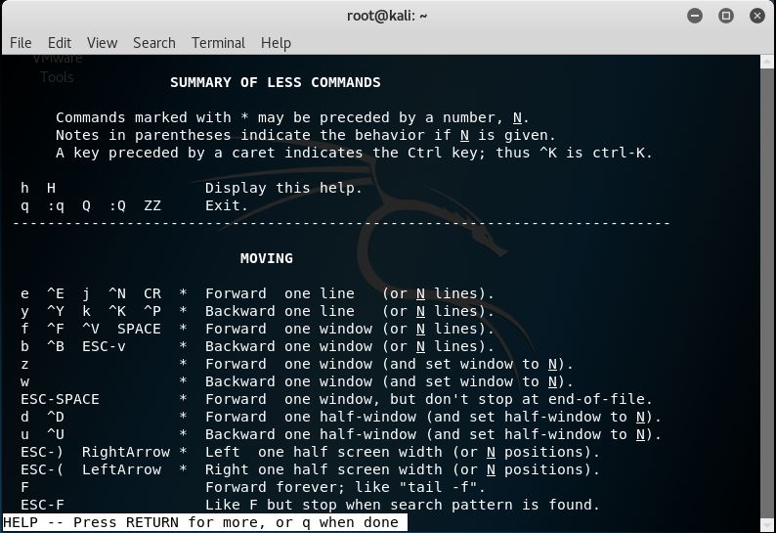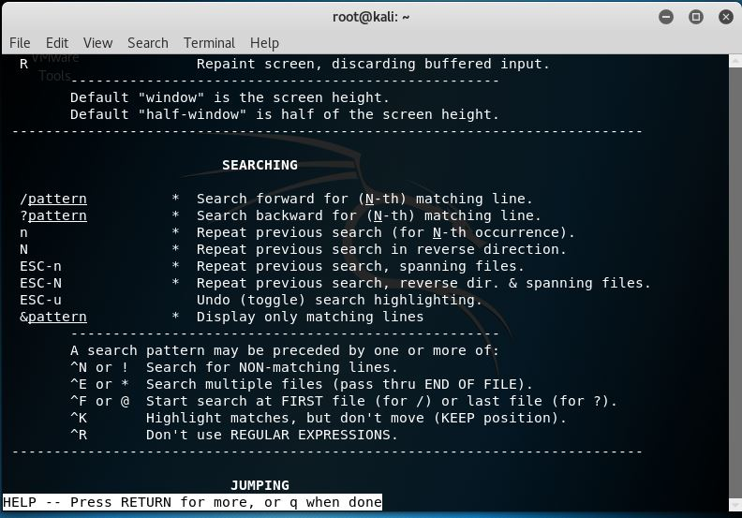

Some of more command options:

-num = specifies an integer which is the screen size (in lines)

-p = do not scroll, instead will clear the whole screen and then display the text

-s = squeeze multiple blank lines into one

Some of less command options:

-a = causes searches to start after the last line displayed on the screen

-c = causes full screen repaints to be painted from the top line down

-e = causes less to automatically exit the second time it reaches end-of-file

1. grep command

-grep is a command-line utility for searching plain-text data sets for lines that match a regular expression. Its name comes from the ed command g/re/p (globally search a regular expression and print), which has the same effect: doing a global search with the regular expression and printing all matching lines

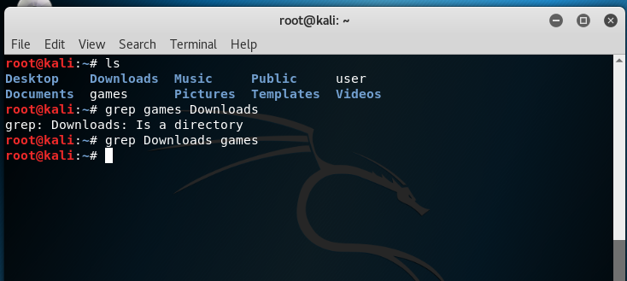

Some of grep command options:

-a = process a binary file as if it were text

-C num = print num lines of leading context before matching lines. Place a line containing – between contiguous groups of matches.

-b = print the byte offset within the input file before each line of output

1. wc command.

Will print the number of newlines, words and bytes in files.

wc syntax: wc [option] file

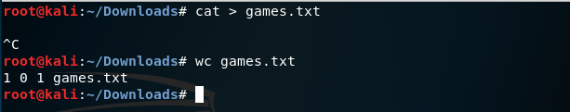

Some of wc command options:

-c = print the byte counts

-m = print the character counts

-l = print the newline counts

-w = print the word counts

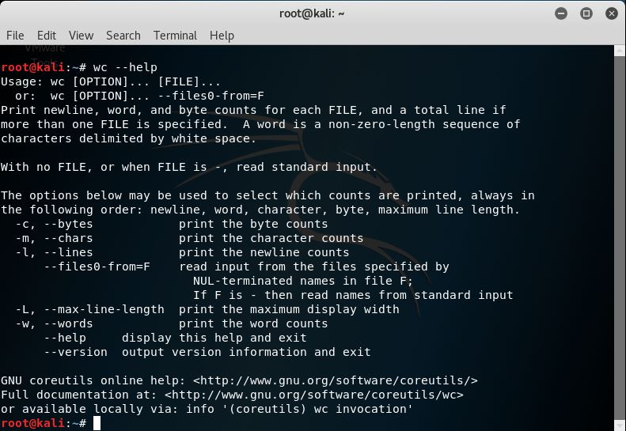

1. kill command.

Used to terminate a process.

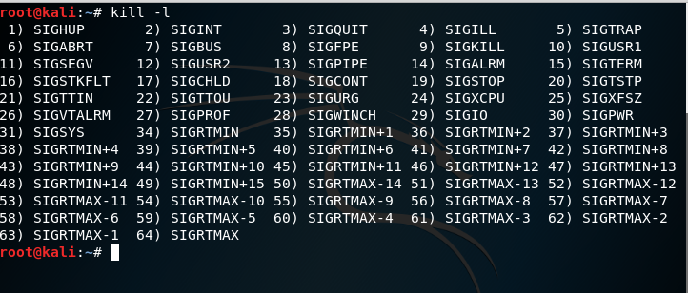kill syntax: kill -l [signal] (simplest form)

Some of kill command options:

-l = prints a list of signal names

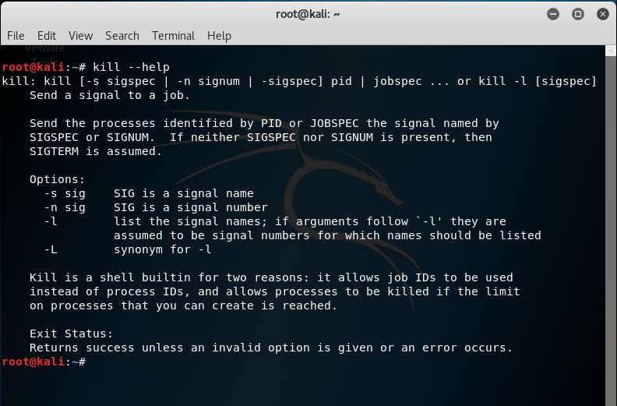

1. ps command.

Will provide information about the currently running processes.

ps syntax: ps [option]

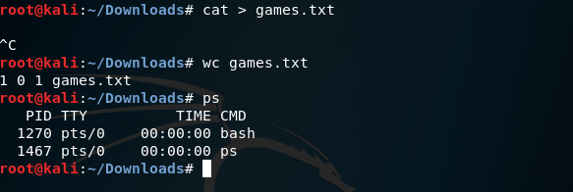

Some of ps command options:

-d = select all processes except session leaders

-e = select all processes

-r = restrict the selection to only running processes

1. top command.

Used to display Linux task.

top syntax: top [option] (simplest form)

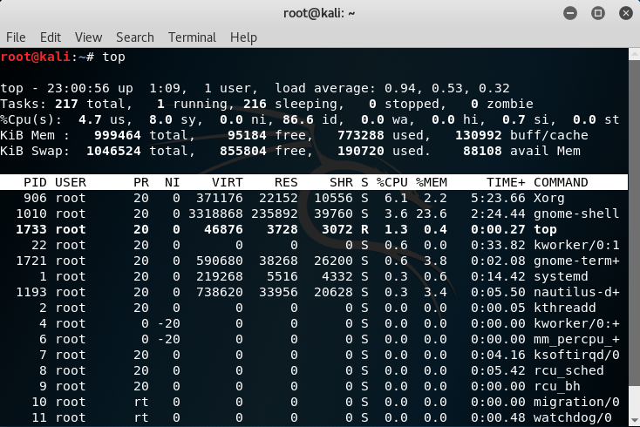

Some of top command options:

-b = starts top in ‘Batch Mode’

-n = specifies the maximum number of iterations, or frames, top should produce before ending

-M = show memory units (k/M/G) and display floating point values in the memory summary

1. uname command.

The command is use to print system information.

uname syntax: uname [option]

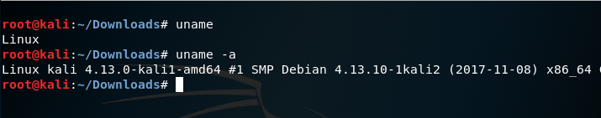

Some of uname command options:

-a = print all information in a default order, except omit -p and -i if unknown

-s = print the kernel name

-p = print the processor type or “unknown”

-i = print the hardware platform or “unknown”

1. uptime command.

Will tell how long the system has been running.

uptime syntax: uptime [option] (option is not necessary)

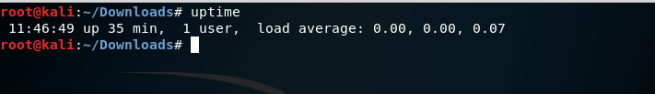

Some of uptime command options:

-h = display a brief help message and exit

-V = display version information and exit

1. ping command.

Send ICMP ECHO_REQUEST packets to network hosts.

ping syntax: ping [option] [option] ….. destination

Note: the syntax can be insert with multiple kinds of option if need be.

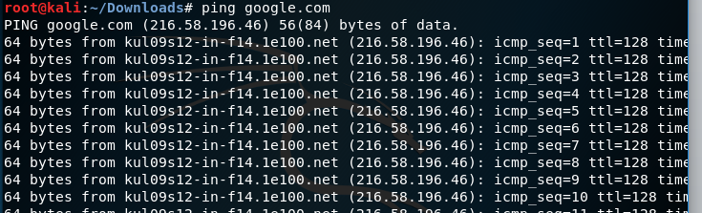

Some of ping command options:

-a = audible ping

-b = allow pinging a broadcast address

-B = do not allow ping to change source address of probes. The address is bound to one selected when ping starts

1. netstat command.

The command is use to print network connections, routing tables, interface statistics, masquerade connections and multicast memberships.

netstat syntax: netstat [option] [option] …..

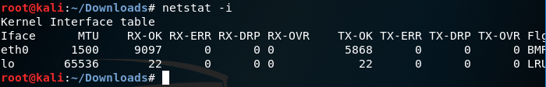

Some of netstat command options:

(none) = by default, netstat displays a list of open sockets with all the configured address families of the active sockets

-g = display multicast group membership information for IPv4 and IPv6

-i = display a table of all network interfaces

-s = display summary statistics for each protocol

1. chmod

-chmod is the command and system call which may change the access permissions to file system objects (files and directories).

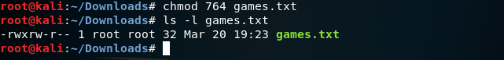

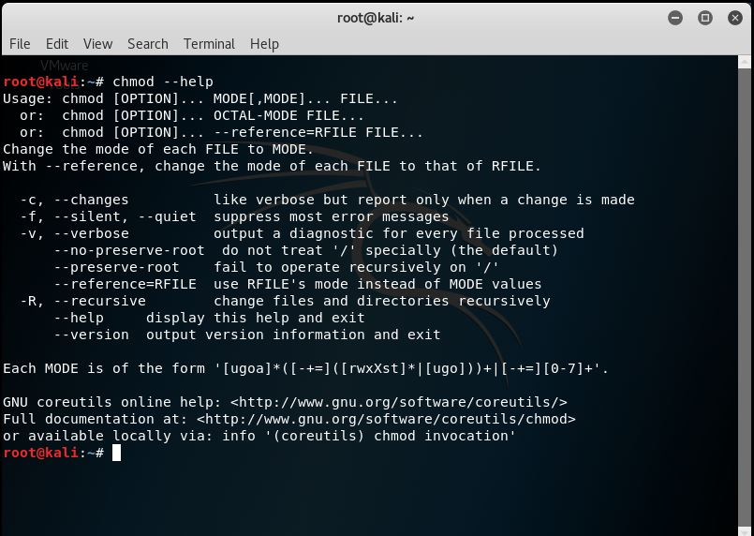

1. chown

-The command chown, an abbreviation of change owner, is used on Unix-like systems to change the owner of file system files, directories. Unprivileged (regular) users who wish to change the group membership of a file that they own.

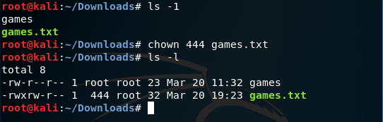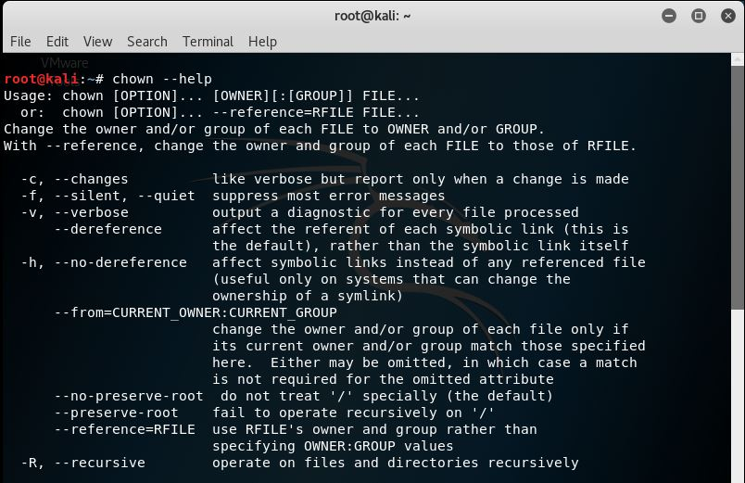

1. ln

The ln command is a standard Unix command utility used to create a hard link or a symbolic link (symlink) to an existing file.

